MISSING CAT
A CRY FOR HELP FOR OUR FURRY FRIEND.

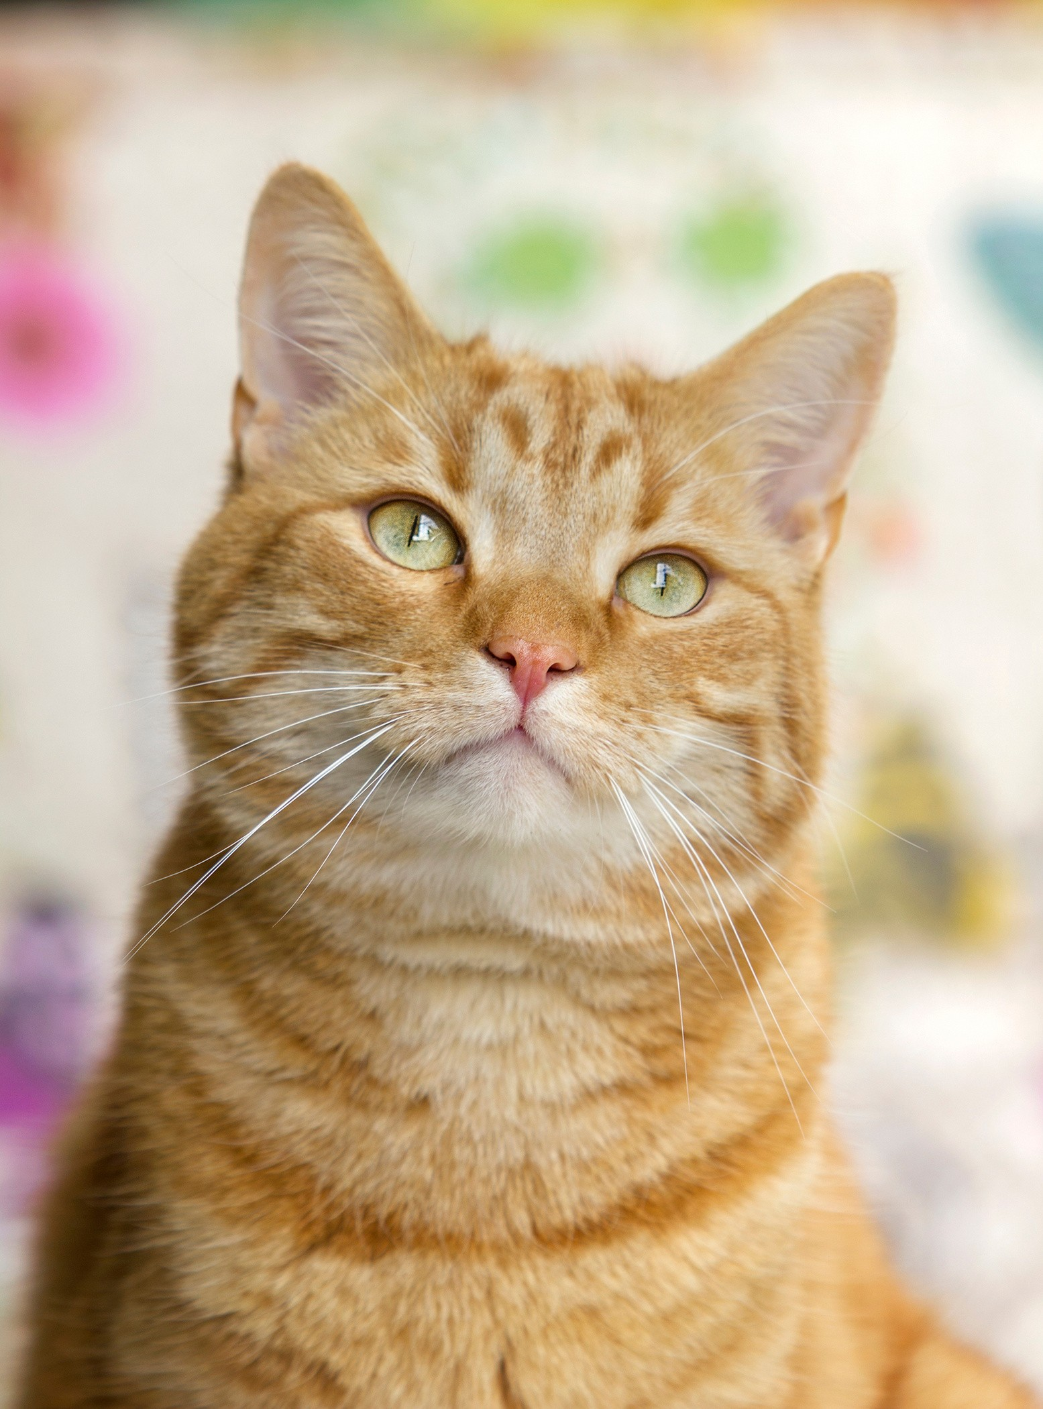
FLUFFY
Last seen: 123 Main St Date: Jan 01, 2030 Color: Orange tabby Sex: Male (neutered)

Fluffy escaped out of an open door and isn't used to being outside. He is likely very scared.
PLEASE DO NOT CHASE

CALL OR TEXT WITH ANY INFORMATION
123-456-7890

